SWA1 A20 Exam Questions

Question 1: The JavaScript object model
- Summarise the JavaScript object model and contrast it to object models from other languages like Java or C#
JavaScript is an object-based language based on prototypes, rather than being class-based. Because of this different basis, it can be less apparent how JavaScript allows you to create hierarchies of objects and to have inheritance of properties and their values
Class-based object-oriented languages, such as Java and C++, are founded on the concept of two distinct entities: classes and instances.
A prototype-based language, such as JavaScript, does not make this distinction: it simply has objects. A prototype-based language has the notion of a prototypical object, an object used as a template from which to get the initial properties for a new object. Any object can specify its own properties, either when you create it or at run time. In addition, any object can be associated as the prototype for another object, allowing the second object to share the first object's properties.
- Explain how ‘this’ works in JavaScript, and how to control it using bind
The bind() method creates a new function that, when called, has its this keyword set to the provided value, with a given sequence of arguments preceding any provided when the new function is called.
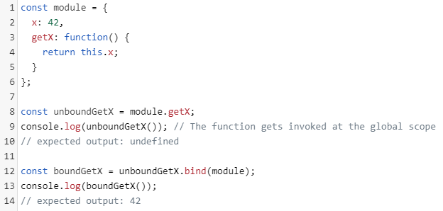

- Use your course assignment 1 to demonstrate
  - the use of prototypes and constructors in creating and using JavaScript objects
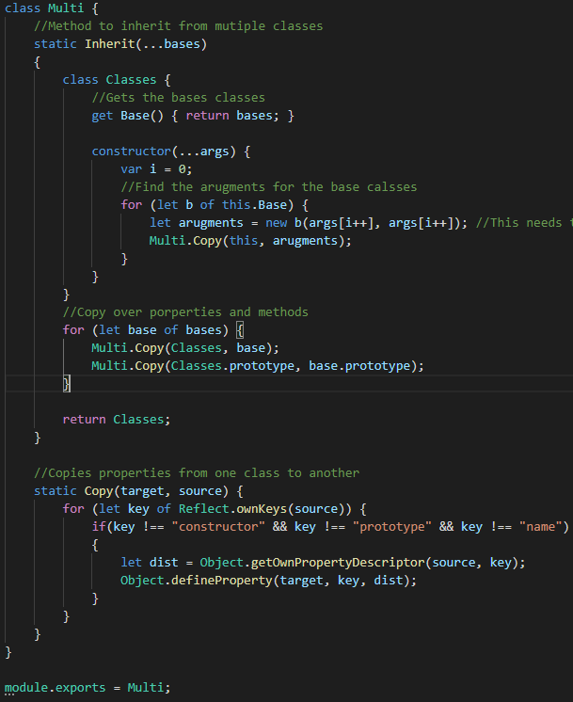

  - the use of factory functions and direct object creation in JavaScript
A factory function is any function which is not a class or constructor that returns a (presumably new) object.
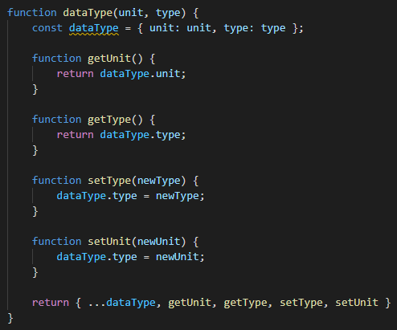

Question 2: Object inheritance in JavaScript
- Use your course assignment 1 to demonstrate concatenative and prototypal inheritance in JavaScript and contrast them.
- Explain the inner workings of the techniques.
- Include use of factory functions, constructors and the class keyword.

Question 3: Functional Programming in JavaScript
- Compare object-oriented and functional programming.
- Summarise functional programming in JavaScript.
- Explain Higher-order functions
- Use your course assignment 2 to demonstrate higher-order functions and their use in JavaScript programming. Include the relevant Array and Function methods as part of your demonstration.

Question 4: Asynchronous programming
- Use your course assignments to demonstrate asynchronous programming in JavaScript
- Explain how the run-time model works with asynchronous programming
- Include callbacks, promises and async/await in your explanation

Question 5: Client/server programming
- Use your course assignments 2 and 3 to demonstrate asynchronous client/server programming using both XmlHttpRequest and fetch
- Compare using promises and async
- Relate to other patterns of communication like web sockets

Question 6: 1-way data flow
- Use your course assignment 3 to demonstrate the flux GUI design pattern
- Compare with other GUI design patterns

Question 7: 2-way data binding
- Use your course assignment 3 to demonstrate 2-way data binding
- Compare with other GUI design patterns

Question 8: Reactive Programming
- Use your course assignment 4 to demonstrate the use of observables in an application
- Relate to the observable design pattern
- Compare with promises
- Explain the use of operators to transform and combine observables

Question 9: Web sockets
- Use your course assignment 4 to demonstrate web sockets
- Explain the use of web socket events and states
- Compare with alternatives

